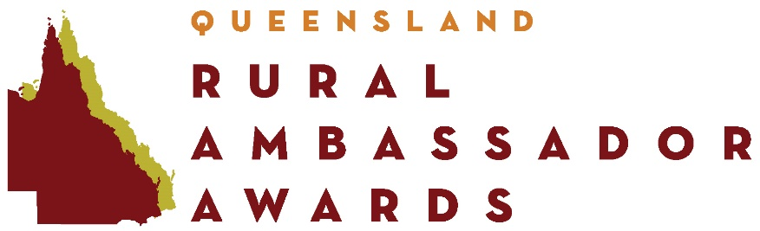

RULES OF COMPETITION
Eligibility
- The award is open to persons born in Australia or naturalised Australians permanently residing in Queensland.
- Entrants must be permanent residents of Australia who have resided in Queensland for a minimum of three (3) months immediately prior to nomination, or if resident near a state border can show they are an active working member of their nominating affiliated Agricultural Society.
- Entrants must be aged 20 and less than 30 years as at 1 May in the year of the competition.
- The award is opened to both males and females either single or married.
- Immediate family members of affiliated Agricultural Societies and QUEENSLAND AG SHOWS committee members and staff are eligible to enter provided they;
  - Declare a pecuniary interest, and
  - Are not involved in any discussion regarding the result during the competition
- Previous state and national winners are not eligible to re-enter the competition.
- State finalists (excluding the winner) are eligible to re-enter the competition after a period of two (2) years. Two state finals must have passed in this period
- Affiliated Agricultural Society winners are eligible to compete in Sub-Chamber finals. In the event that the winner becomes ineligible or unavailable the runner-up becomes eligible to represent the Agricultural Society.
- The Sub-Chamber finals winner is eligible to compete in the State Final. In the event that the Sub-Chamber winner becomes ineligible or unavailable the runner-up becomes eligible to represent the Sub-Chamber.
- The State final winner is eligible to compete in the National final. In the event that the winner becomes ineligible or unavailable the runner-up becomes eligible to represent Queensland.

Local Show Competition
- Entrants must be nominated by an affiliated Agricultural Society to be eligible to enter a Sub-Chamber final.

Criteria
- Entrants should be actively involved, or demonstrate a readiness to become actively involved in, their local Agricultural Society and Agricultural Show. They should also be knowledgeable about current rural issues pertaining to their local area, Queensland and Australia and have a strong affiliation towards agriculture.

- Tertiary qualifications are not a prerequisite for the Rural Ambassador Award and will have no influence in the selection process. The Award seeks to attract all young rural people who symbolise the rural spirit – people with vitality, who are forward thinking and with a passion for the land and local Agricultural Shows.

Entry Forms
- At Local, Sub-Chamber and State level all entries must include a completed entry form, accompanied by a completed questionnaire, recent photograph (in high resolution electronic format) and a covering letter. Failure to provide the above documentation will deem the entry invalid.

Awards
- Prizes awarded to Rural Ambassadors are not transferable. All prizes are subject to change without notice and when the prize is a voucher or bursary the voucher and bursary will expire at its expiration date.

State Finals
- State Finalists should be available for a minimum of three (3) full days to participate in all activities associated with the State Final held during the Royal Queensland Show. Should there be any concerns with timeframes the State Coordinator is to be advised immediately.
- State finalists must participate as part of the group during the entire itinerary. If unable to do this they must withdraw from the contest and the runner-up will be invited to take their place.
- State Winner and Runner Up are required to commit to a further three (3) days attendance at the Royal Queensland Show as per the Rural Ambassador Itinerary. Should there be any concerns with timeframes the State Coordinator is to be advised immediately.
- Travel to and from Brisbane and whilst in Brisbane is the responsibility of Finalists. This may be subsidised by the nominating Sub-Chamber and / or Agricultural Society (at their discretion).
- State Finalists must accept that any behaviour that will bring disrepute to these Rural Ambassador Awards and is deemed inappropriate by the organising committee, prior to or during the State Finals, may forfeit their right to participate.
- State Finalists will be asked to adhere to a dress code, information is released directly to the finalist.

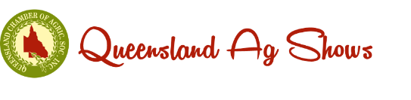

Rural Ambassador RulesVersion 2 – January 2020

