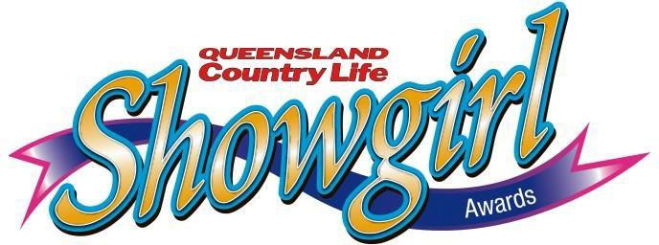

SHOWGIRL AWARDS NOMINATION FORM

Coordinator USE ONLY

Local Show:
⎦ WINNER Runner Up

Sub Chamber:
⎦ WINNER Runner Up
◻State Invitation Sent

LOCAL SHOW & SUB CHAMBER JUDGING

All Show Dates and Contact details can be found at www.queenslandshows.com.au
Please complete information below in Clear CAPITAL LETTERS.
Competitor Information
Nominating Society Full Name Email Date of Birth / / Age (at 1ST of August)
Mobile Home Phone (07) Street Address Suburb Postcode
Sub Chamber Occupation

Entrants Declaration:
I have read and understood the “Showgirl Awards Conditions of Entry” Nomination Criteria, Regulations and By-laws and agree to be bound in all respects by these Rules & By-Laws of QCAS. I also consent and agree QCAS and show societies have the right to take or use photographs of me (and/or my property) and use the photos in any and all marketing and media worldwide including online, now or in the future.

False or misleading information given by the entrant may lead to disqualification from this event and for the duration of the competition.

Signature of Applicant Date Signature of Local Showgirl Organiser
PROCESSING INSTRUCTIONS:
All entrants must complete a Nomination Form and submit all required documents to the Local Agricultural Show you are competing in prior to the Judging Date. This form will be used for Local and Sub Chamber competitions.

LOCAL SHOW – The Show Society Secretary or designated coordinator is to forward the Local Show Winner and Runner Up Entry Form & required documents to Sub Chamber Secretary for processing within 14 days of the competition conclusion. Please keep a copy for your records.

SUB CHAMBER FINALS – The Sub Chamber Secretary is to forward Sub Chamber Finals Winner and Runner up Entry Form and required documents to the Queensland Ag Shows Head Office competitions department within 14 days of competition conclusion to qualify for State Finals. competitions@queenslandshows.com.au or post to PO Box 240, ROCKLEA QLD 4106.

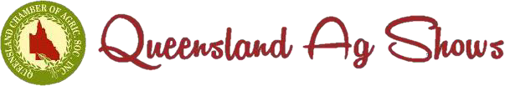

SHOWGIRL AWARDS – PROFILE FORM “A”

LOCAL SHOW & SUB CHAMBER JUDGING

Full Name:

Education:
Senior School Attended:

Level Achieved:

Further Qualifications:

- Current Occupation and Career Aspirations (100 words or less):

- Sporting Interests and Hobbies (100 words or less):

- Current Community Involvement / Volunteer Roles (100 words or less):

- Ambitions and Life Goals (100 words or less):

- Why would you like to be a Showgirl (150 words or less):

- What skills and knowledge do you need to become a Showgirl (150 words or less):

- What do you think the role of being a Showgirl entails (150 words or less):

- What is your most embarrassing or cherished childhood memory (100 words or less):

SHOWGIRL AWARDS – MEDICAL FORM

LOCAL SHOW & SUB CHAMBER JUDGING

MEDICAL INFORMATION
Name
Show Society
Sub-Chamber
Date of Birth
Medicare Number

Dietary Requirements
Eg. Vegetarian, gluten free

Heart Problems | yes/no
Respiratory Problems | yes/no
Allergies | yes/no
Travel Sickness | yes/no
Blood Pressure | yes/no
Operations | yes/no
Epilepsy | yes/no
Recent illness Injections | yes/no
Eg. Tetanus | yes/no
Drugs required | yes/no
Phobias | yes/no
Diabetes | yes/no
Other:

Emergency Contact
Name
Phone Number
Mobile

Signed Date
Page 5 of 6

SHOWGIRL AWARDS - DECLARATION FORM

LOCAL SHOW & SUB CHAMBER JUDGING
Name:

Phone:

Email:

Entrants Declaration:

I have read the Rules and Conditions of Entry of the Showgirl Awards and agree to the conditions set by the Committee and confirm the details below:

- I am a woman who is an Australian citizen and I reside in Queensland, or I am closely affiliated with a Queensland Agricultural Show. I am aged between 18 and 28 years inclusive as at 1 August in the year of the competition.
- I will make the necessary arrangements with my employer or if applicable my educational institution to have leave of absence for the State Final of the Showgirl Awards being held during the Royal Queensland Show. If I am successful in winning, I will make the necessary arrangements to fulfill my commitments until the
‘People’s Day’ holiday.
- I agree to participate in the full duration of the State Final itinerary and I am prepared to work with the other finalists as a group during the State Final.
- If I win a prize and I do not abide by the Conditions set down by the Committee, I agree to automatically forfeit any prizes and title associated with the Awards.
- If necessary, I will make suitable arrangements with the Host Hotel upon checking in at reception to ensure that I will be responsible for any additional personal expenses incurred by me which are not included in the sponsorship arrangement.
- I have completed all forms.
  - Entry Form
  - Profile Form A
  - Medical Information Form
  - Declaration Form

- The information contained in these forms and this Declaration Form, is not to be disclosed to anyone not associated with the Showgirl Awards without my written consent.
- I accept that any behaviour that will bring disrepute to the Showgirl Awards and is deemed inappropriate by the Showgirl Committee, prior to or during Local, Sub Chamber and State Final competitions, may forfeit my right to participate.

Signature | Date

Page 6 of 6

[T y p e h e r e ] [T y p e h e r e ] [Type here]

